**Department of Computer Science and Engineering**

| **Course Code: CSE 370** | **Credits: 3.0** |
| --- | --- |
| **Course Name: Database Systems** |  |

**Lab Homework 3**

**Table create:**

CREATE TABLE employees (

employee_id CHAR(10) NOT NULL,

first_name VARCHAR(20) NOT NULL,

last_name VARCHAR(20) NOT NULL,

email VARCHAR(60) NOT NULL,

phone_number CHAR(14),

hire_date DATE NOT NULL,

job_id CHAR(10) NOT NULL,

salary INT,

commission_pct DECIMAL(5,3),

manager_id CHAR(10),

department_id CHAR(10),

PRIMARY KEY (employee_id)

);

**Insert into:**

INSERT INTO employees (employee_id, first_name, last_name, email, phone_number, hire_date, job_id, salary, commission_pct, manager_id, department_id)

VALUES

('EMP001', 'Shihab', 'Muhtasim', 'shihab@gmail.com', '01554375947', '2021-01-01', 'JOB001', 70000, 5, 'MNG001', 'DPT001'),

('EMP002', 'Martin', 'Garrix', 'garrix@gmail.com', '01563747483', '2023-01-02', 'JOB002', 40000, 0.3, 'MNG001', 'DPT001'),

('EMP003', 'David', 'Scooper', 'david@gmail.com', '01673837477', '2022-01-03', 'JOB002', 55000, 0.43, 'MNG001', 'DPT002'),

('EMP004', 'Harry', 'Potter', 'harry@gmail.com', '01364983827', '2022-01-04', 'JOB003', 85000, 0.02, 'MNG002', 'DPT007'),

('EMP005', 'charls', 'Brown', 'charls@gmail.com', '01925463737', '2022-01-05', 'JOB004', 37000, 2, 'MNG002', 'DPT003'),

('EMP006', 'Awsaf', 'Hossain', 'awsaf@gmail.com', '01336474737', '2020-09-03', 'JOB001', 70000, 0.5, 'MNG001', 'DPT007'),

('EMP007', 'Arik', 'Hassan', 'arki@yahoo.com', '01735367484', '2021-02-02', 'JOB005', 40000, 0.3, 'MNG003', 'DPT001'),

('EMP008', 'Misha', 'Jarin', 'misha.jarin@yahoo.com', '01390984576', '2022-05-03', 'JOB004', 55000, 0.4, 'MNG003', 'DPT005'),

('EMP009', 'Ayesha', 'Tasnia', 'ayesha.tasnia', '01427738440', '2019-01-04', 'JOB005', 85000, 0.25, 'MNG004', 'DPT002'),

('EMP010', 'David', 'Guetta', 'guetta@gmail.com', '01835638300', '2021-07-05', 'JOB006', 37000, 0.2, 'MNG005', 'DPT005');

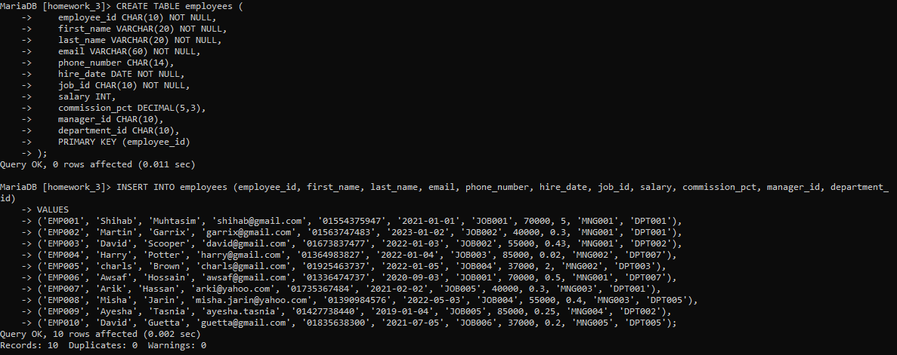

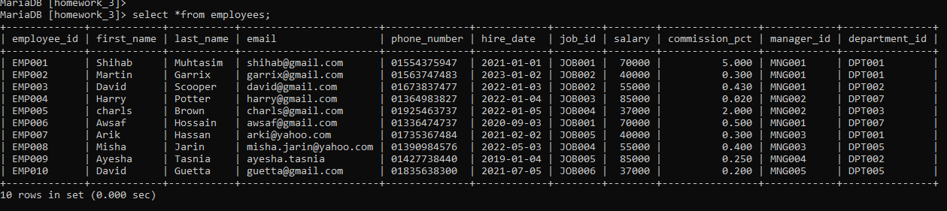

**Task 1:**

SELECT first_name, last_name, email, phone_number, hire_date, department_id FROM employees WHERE hire_date = (SELECT MAX(hire_date) FROM employees);

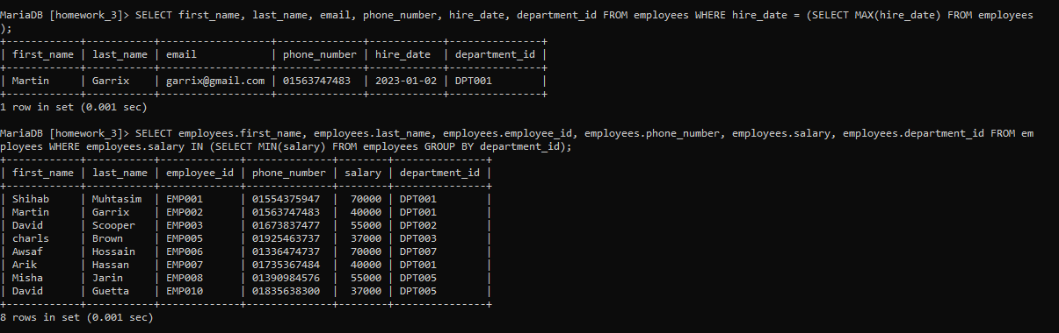

**Task 2:**

select first_name, last_name, employee_id, phone_number, salary, department_id from employees where (department_id, salary) in (select department_id, min(salary) from employees group by department_id) order by department_id;

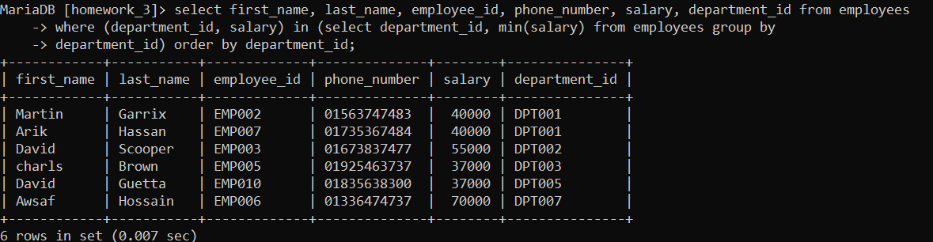

**Task 3:**

SELECT first_name, last_name, employee_id, commission_pct, department_id

FROM employees WHERE department_id = 'DPT007' AND commission_pct < ALL (SELECT commission_pct FROM employees WHERE department_id = 'DPT005');

**Task 4:**

SELECT department_id, COUNT(*) AS total_number_of_employees FROM employees WHERE department_id NOT IN (SELECT department_id FROM employees WHERE salary > 30000) GROUP BY department_id;

*Task 3 and 4:*

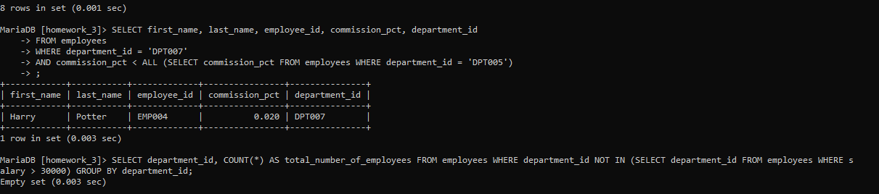

**Task 5:**

SELECT department_id, job_id, commission_pct FROM employees e1 WHERE commission_pct < ANY (SELECT commission_pct FROM employees e2 WHERE e1.department_id = e2.department_id AND e1.job_id != e2.job_id);

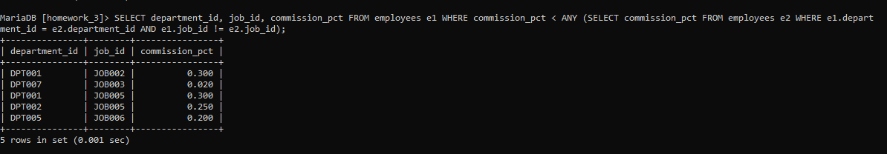

**Task 6:**

SELECT DISTINCT manager_id FROM employees WHERE manager_id NOT IN (SELECT DISTINCT manager_id FROM employees WHERE salary < 3500);

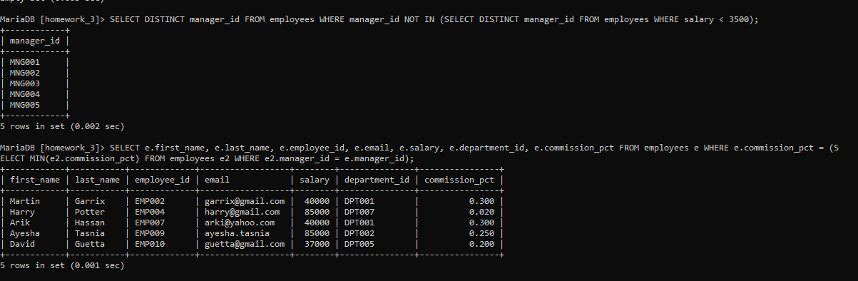

**Task 7:**

select first_name, last_name, employee_id, email, salary, department_id, commission_pct from employees where commission_pct in (select min(commission_pct) from employees group by manager_id);

